- Title: Did You know About the Financial Designer Set-up Filter?
When accessing the Financial Designer Set-up, you are prompted to Select Active or Inactive Companies and then can select a specific Company to load into the Set-up area. By filtering on Active Properties (or a Specific Property) this improves performance when accessing and saving changes within the Financial Designer Set-up. Yet another way to save time and money!

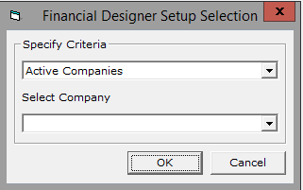

- Title: Did You know about the Financial Designer Layout Filter?
If you have access to the Financial Designer Layout you have access to an enhanced filter that allows you to filter by Line Items that are not part of the report layout. This is an easy way to access and add items that are not part of the existing report. The range filter also gives you the ability to add groups of accounts to a financial.
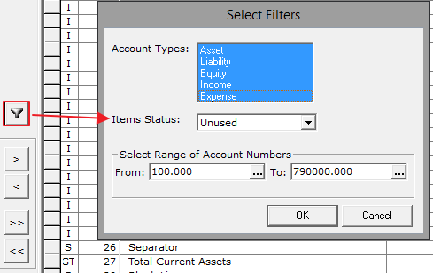

- Title: Did you know GL Accounts automatically update to Financial Designer Setup?
Verbiage: Do you create new GL Accounts and update the Financials? If so, you will love this! Check out the defaulted checkbox option when creating new GL Accounts that will auto add the new account to the Financial Designer Setup for you. Yes, you read that right, adding without all the work!
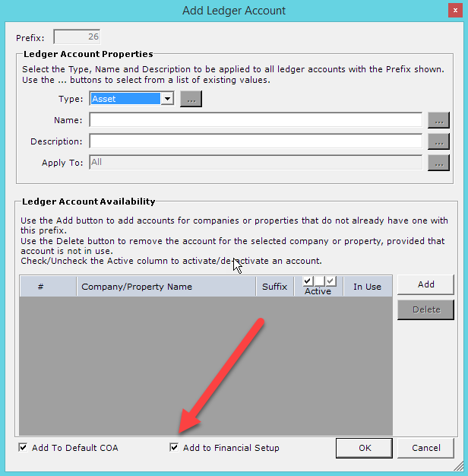

- Title: Did you know you can write multiple checks to the same vendor in one check run?
Verbiage: The AP Module Vendor allows you to print multiple checks per Vendor on one check run! The AP Manager doesn’t need to complete separate check runs to pay the same Vendor with multiple checks. This saves you time and money!!

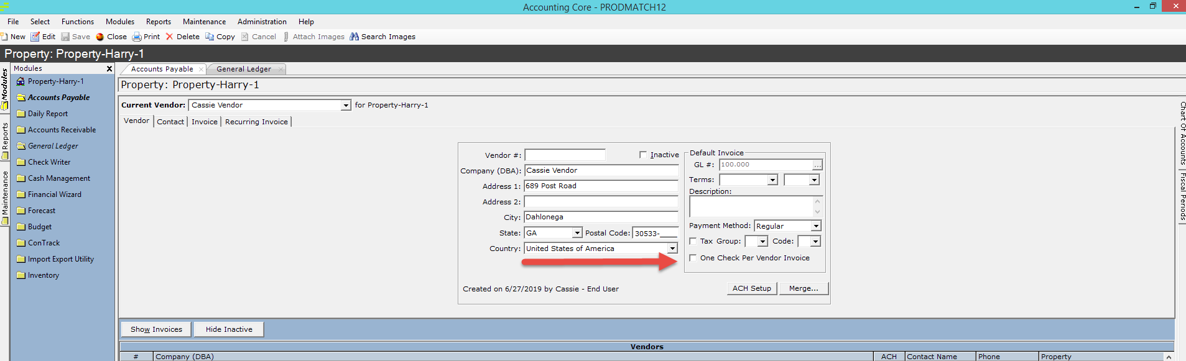

- Title: No Paper, No Problem. ACH Vouchers Go Digital!
Verbiage: Go paperless – save a tree! You don’t need to print ACH Vouchers when you pay your Vendors through Check Writer, which saves you time and money. In Check Writer, when you click on the ‘Process Payment’ button, choose the “No” option and viola… no more wasted paper!

